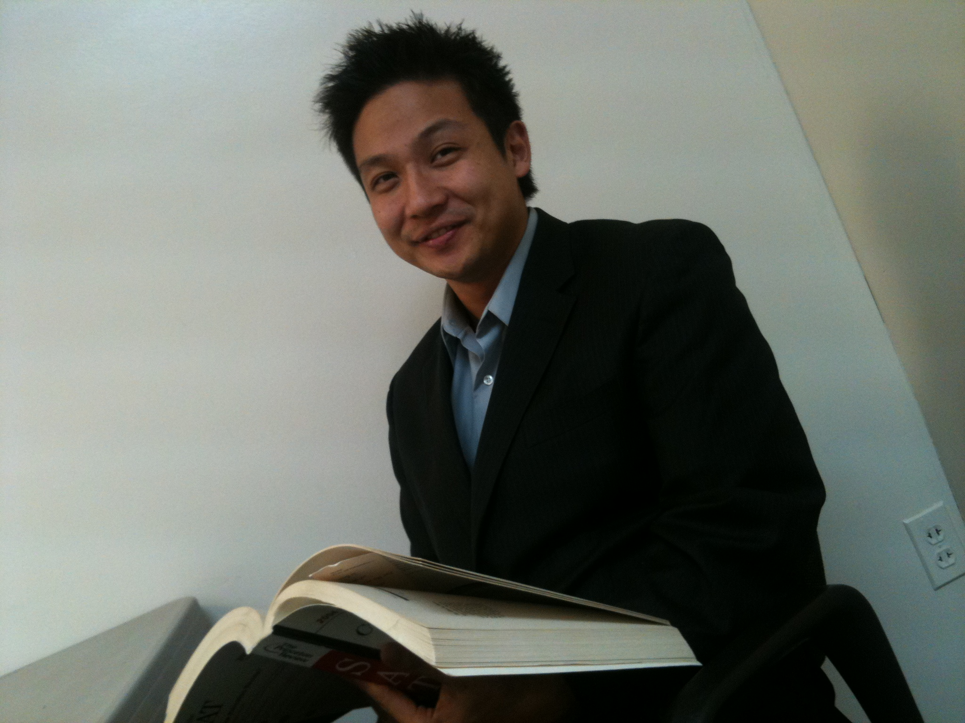

(Momentarily in Incheon, Korea)
010 – 2746 – 3205
Da_Truth4Life@Hotmail.com

Objective: To seek a job where I can fully utilize my versatile ability to serve, help and
contribute to the community with my bilingual skill and diverse experiences.
Education
(2008 ~ 2010) | Liberty University (Graduated with B.S. in Education) | Virginia

Experience
Dates | Length | Name | Position | Subjects | Grades/Age | Location
9/1997~9/1999 | 2 years | Private Tutoring | Teacher | Conversation | Elementary Sch. | Incheon, Korea
9/1998~5/1999 | 9 months | Orphanage | Teacher | Alphabet  Grammar | Elementary Sch. | Incheon, Korea
9/1998~5/1999 | 9 months | Nursing Home | Teacher | Computer  Alphabet | Adults | Incheon, Korea
8/2002~8/2004 | 2 years | Private Tutoring | Teacher | ESL  Conversation | Middle Sch.  High Sch. | Seoul,  Korea
5/2003~8/2004 | 1 year  3 months | ECC | Teacher | ESL  Business English  Conversation | High Sch.  College  Adults | Seoul, Korea
9/2004~5/2005 | 9 months | Tutoring Program @ School | Teacher | ESL  English | College Sch.  Adults | NY, USA
5/2005~10/2005 | 6 months | Cho Dae Church | Teacher | English  Math | Middle Sch. | NY, USA
10/2005~8/2006 | 1 year  3 months | Ace Academy | Teacher  Manager | ESL  English  Conversation | Middle Sch.  High Sch.  Adults | PA, USA
8/2006~1/2011 | 4 years  6 months | AP Academy | Teacher | ESL  TOEFL  Conversation  Math | Middle Sch.  High Sch.  Adults | PA, USA
7/2011~Current | 2 years | Korea International Christian School | Teacher | English | High School | Bucheon, Korea
Total Teaching | 15 Years  2 Months

Professional Objectives
General English - Middle School, High School students
TOEFL – Middle School, High School students, College, Adults
ESL students Elementary school, Middle School, High School students, College, Adults)
Administration (International Students Related)

Certificate
TESOL Certificate (2006) (60 Hours)
AACS Teaching Certificate

Ability
Fluent in Korean & English

Confidential Information provided upon Request

