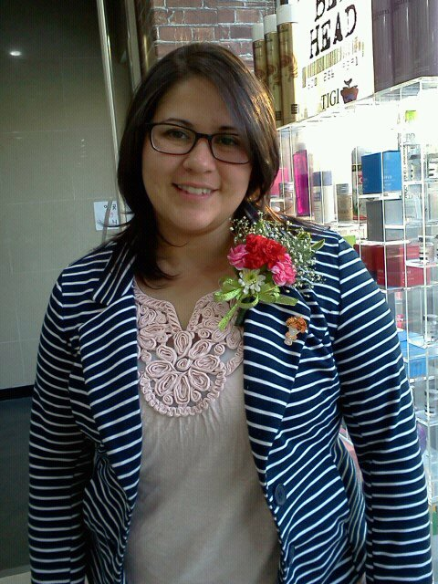
Heather Yzaguirre
- HeatherYzaguirre@gmail.com • 이탱원동 246-9 • 용산구 • 서울 • 010-6472-8062

I’m currently an English teacher at an all boys public school in Pyeongtaek, Gyeonggi-do and have enjoyed it very much for 2 years, although I hope to find a new school in the Seoul area so I can pursue my passions of filmmaking and writing more easily in addition to teaching.

Education

Florida State University, Tallahassee, FL
Bachelor of Science in English, Creative Writing
Minor in Film Studies
December 2009

Relevant Experience

- Published works in Aviano Vigileer and Stars and Stripes Europe Newspapers
- 2 years experience teaching in Korean public school
- Some experience working with kids of all ages in hagwon and public American school

Internships

08/09 – 12/09 FSU Film School, Miscellaneous Crew, Tallahassee, Fl
- Production Assistant, Picture Day, Director: Ken Adachi
- Production Assistant, S.p.a.g.h.e.t.1, Director: Adam Varney

08/09 – 12/09 Thoughts.com, Brand Ambassador, Winter Garden, Fl
- Organizing fundraisers for nonprofit charities
- Promoting the Positive Thoughts Campaign
- Completed internship independently via email/phone from Tallahassee, Fl

01/04 – 05/04 Visual Information Center, Intern, Aviano Air Base, Italy
- In studio training: passport photos, portraits
- Acquired a useful variety of photography techniques
- Post photo training; Photoshop editing/touch-up and PageMaker layout
- On-Site photography experience

Employment

03/12 – 06/12 Avalon English Institute, Substitute Teacher, Pyeongtaek, South Korea
- Teaching Elementary, Middle and High School students

09/2010 – 09/12 ShinHan Middle School, ESL Teacher, Pyeongtaek, Gyeonggi-do, South Korea
- Conducting English Team Teaching Classes alongside a Korean Teacher
- Independent Classes
- Preparing teaching materials and activities for lesson plans
- Conducting English winter and summer camps for students during vacation
- Providing extra curricular activities related to teaching English

03/10 – 06/10 Randolph Independent School District, Substitute Teacher, Converse, TX
- Teaching Elementary, Middle and High School students

1/09 – 08/09 FSU Writing Center, Tutor, Tallahassee, FL
- Tutoring students and maintaining files
- Editing works varying from creative to research and thesis papers

10/06 - 10/07 Florida Sterling Council, Office Assistant, Tallahassee, Fl
- Copy Editing on office documents
- Assembling company course materials
- Answering phones, organizing files, communicating with customers
- Event planning for the 15th Annual Sterling Conference

05/01 – 01/04 Public Affairs, Staff/Correspondence Writer, Aviano Air Base, Italy
- Published articles once a week
- Copy writing
- Photography and Layout Editing

