 | Sheila Grace Bridgman
2/3/2011
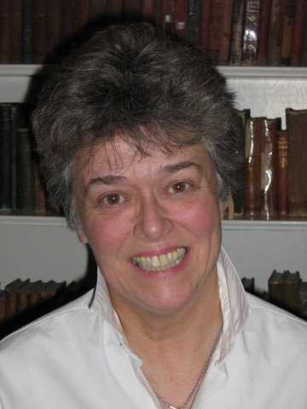 | Address: Chungnam, Boryeong City, Dong Dae Dong,1027  Goon Ga Dwin Dup Officetel, #501  Cellphone: 010 8377 0804  Email: bridgbit1@aol.com

work hISTORY/ EXperience
ENGLISH TEACHER SOUTH KOREA:
Teaching all levels and all ages: individuals, small groups, large classes.
2009 - 2010 Chungnam Board of Education Boryeong City
2001 - 2003 Namseoul University Cheonan
2000 - 2001 Andong National University Andong City
1999 – 2000 E.C.C. Private School Anyang City
1996 - 1998 Juseoung College Cheong Ju City

MUSICIAN:
String bass player in the following orchestras.
1978 – 1987 Canadian Opera Company Toronto, ON.
National Ballet of Canada Toronto, ON.
1987 – 1995 Piano Teacher Toronto, ON.
CARE:
Tutor, assist, train, people with disabilities.
2005 – 2009 Walkerton Community Living Walkerton, ON.
2005 – 2009 Gassinger Home Durham, ON.

SELF EMPLOYED:
Designed and manufactured musical instrument cases for string players.
1985 – 1995 Grace Case Toronto, ON.
Skills

Leadership and Organizational
Acting as a role model for students in personal presentation and enthusiasm for learning
Using my time effectively to set and achieve goals, determine realistic priorities and work to deadlines
Showing the capacity for creativity in lesson implementation
Working co-operatively in a team environment in planning and implementing programs for students
Presenting education programs to suit the varying cognitive levels, backgrounds and ages of students
High level proficiency on Piano and String Bass
EDUCATION
1974 – 1977 Diploma in Music Performance University of Toronto
1992 – 1995 Bachelor of Fine Art York University
1988 – 1991 Creative Arts Certificate Georgian College
1977 Grade 10 Piano Royal Conservatory
REFERENCES
Okkye Elementary School, Boryeong, South Korea
Co- Teacher, Jang Eun Ah Ph:016-415-9161
Vice Principal, Kim Jong Soon Ph:041-936-7172

