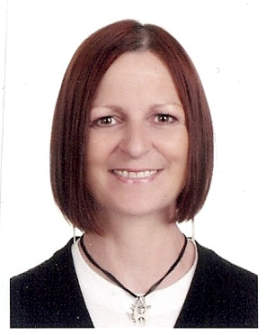

Curriculum Vitae
Gillian Scott Dempster
2nd Floor, 214-22, Itaewon-dong, Yongsan-gu, Seoul, South Korea
gillyuchechukwu@yahoo.co.uk 010-6874-2409

Education professional with 7 years international experience as a full time consultant for Macmillan Publishing, Korea. Extensive writing, presenting and training experience primarily focused on young learners.

Education
MA English and Sociology 1997
Aberdeen University, UK

Access to Primary School Teaching Course 1993 Aberdeen College, UK

Montessori Nursery Correspondence Course 1992
London Montessori Centre, UK

TESOL Certificate 1998
Trinity College, London, UK

Professional Experience
English Teacher March 2012 – Feb 2013
MBC KidsnWise, Songpa campus, Seoul

- Teaching English to kindergarten and early elementary school students

English Teacher August 2011 – Feb 2012
MBC KidsnWise, Banpo campus, Seoul

- Teaching English to kindergarten and early elementary school students

Consultant Feb 2004 - 2011
Macmillan Korea Publishers Limited

Writing
- Wrote six workbooks for a reading anthology for the Korean market
- Wrote testing materials to supplement courses and adapted Japanese textbooks for the Korean market
- Reviewed new educational materials and gave feedback to enhance the products
- Involved in the recording of the above materials
- Editor for a co-published children’s course (Macmillan and Chinese publisher)

Presenting
- Presented and trained in Korea, Taiwan, China, Thailand and Vietnam
- Preparing and giving presentations for users of Macmillan products or training within specific areas in the ELT field, such as how to teach reading and or speaking
Training
- Teacher training for Macmillan products
- Making interesting and stimulating resources to aid the teaching of children
- Attending and presenting at conferences
- Setting up programs for different schools, customer care and school visits
- TESOL and Y-TESOL Trainer at various universities in Korea (Sookmyung, Ewha, Konkuk)

Presenter and English Teacher April 2003 – Feb 2004
Eastern English, Guri City, Korea
Macmillan Korea Publishers Limited, Seoul, Korea

- Taught English to elementary and middle school students
- Prepared and gave educational related presentations with question and answer sessions

English Teacher January 2001- March 2003
Jung Chul Institute, Seoul

- Taught English to kindergarten, elementary and middle school students
- Created imaginative and effective lesson plans
- Chose stimulating and suitable text books
- Wrote role-play dialogues to enforce new language through real situations
- Wrote songs and used games to reinforce the target language and keep it fun
- Focused on solving common problems - i.e. pronunciation
- Plan events such as festivals and open classes
- Wrote test papers

References

Available on request

