Mohamed Jesil Jeslan Marikkar 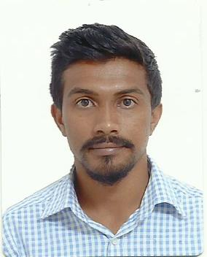
English Teacher
E-mail: JeslanJaseel@live.com
Mobile: +960-9128535
WhatsApp: +960-9128535

Career objectives:
To pursue a career as a English Teacher. It’s challenging and recognized profession, the Demand for which
Is very high in schools and colleges. I am looking for an opportunity to join a Dynamic, ambitious and growing
School or college to forge a career. Capable of working in minimum supervision and committed to providing high quality teaching to every students.

Professional Experience:
- Lanka Optic (Pvt) Ltd, Sri Lanka
2011 August to 2012 August Sales Representative.
2012 September to 2014 September Junior Accountant.
2015 August to 2016 October Assistant Manager.

- Rauff Construction
2015 January to 2015 June. Junior Quantity Surveyor.

- The Wiz Company (Pvt) Ltd, Maldives
Since 2017 January Civil Engineer / Quantity Surveyor

Educational Qualification:

- Success Fully Completed EDXCEL IGCSE OL (June 2011) at Negombo South International School
- Chemistry B
- Biology C
- Mathematics C
- Physics C
- Information and Communication Technology D
- English Language E
- Human Biology E

- Successfully completed Sri Lankan G.C.E O/L Conducted by the department of Examination
- English A
- Science C
- Islam C
- Information Technology C
- Mathematic S

- Successfully completed LEVEL 3 & LEVEL 5 IVQ IN CONSTRUCTION (QUANTITY SURVEYING)

- Applied Scientific Techniques 2 Merit
- Drawing and Surveying Technique 2 Merit
- Construction Techniques 2 Merit
- Tendering, Estimating and Quantity Surveying 4 Pass
- Architectural Design 4 Merit
- Site Surveying 3 Merit
- Construction Management and Law 4 Pass

- Successfully Completed Diploma in Microsoft Office.
- Skills:
- Self-Management and quick adoption to any kind of situation.
- Excellence Working Capability in all office packages.
- Experience in organizing and conducting campaigns.
- Through knowledge in health, safety, quality and environmental procedures of company.
- Excellence communication abilities.
- Preparation of Bills of Quantities.
- Levelling sewer & water pipelines.
- Setting out buildings
Personal Information:
Name : Mohamed Jesil Jeslan Marikkar
Date of Birth : 13th March 1995
Sex : Male
Nationality : Sri Lankan
Religion : Islam
Marital Status : Single
Language Skills : English, Tamil, Sinhala and Dhivehi.
Reference: Can be provided if necessity
I do hereby certify that the above information is true and accurate to the best of my knowledge.
Mohamed Jesil Jeslan Marikkar

