Devin Doyle

3821 Marcom Street, Raleigh, NC, U.S.A. 27606
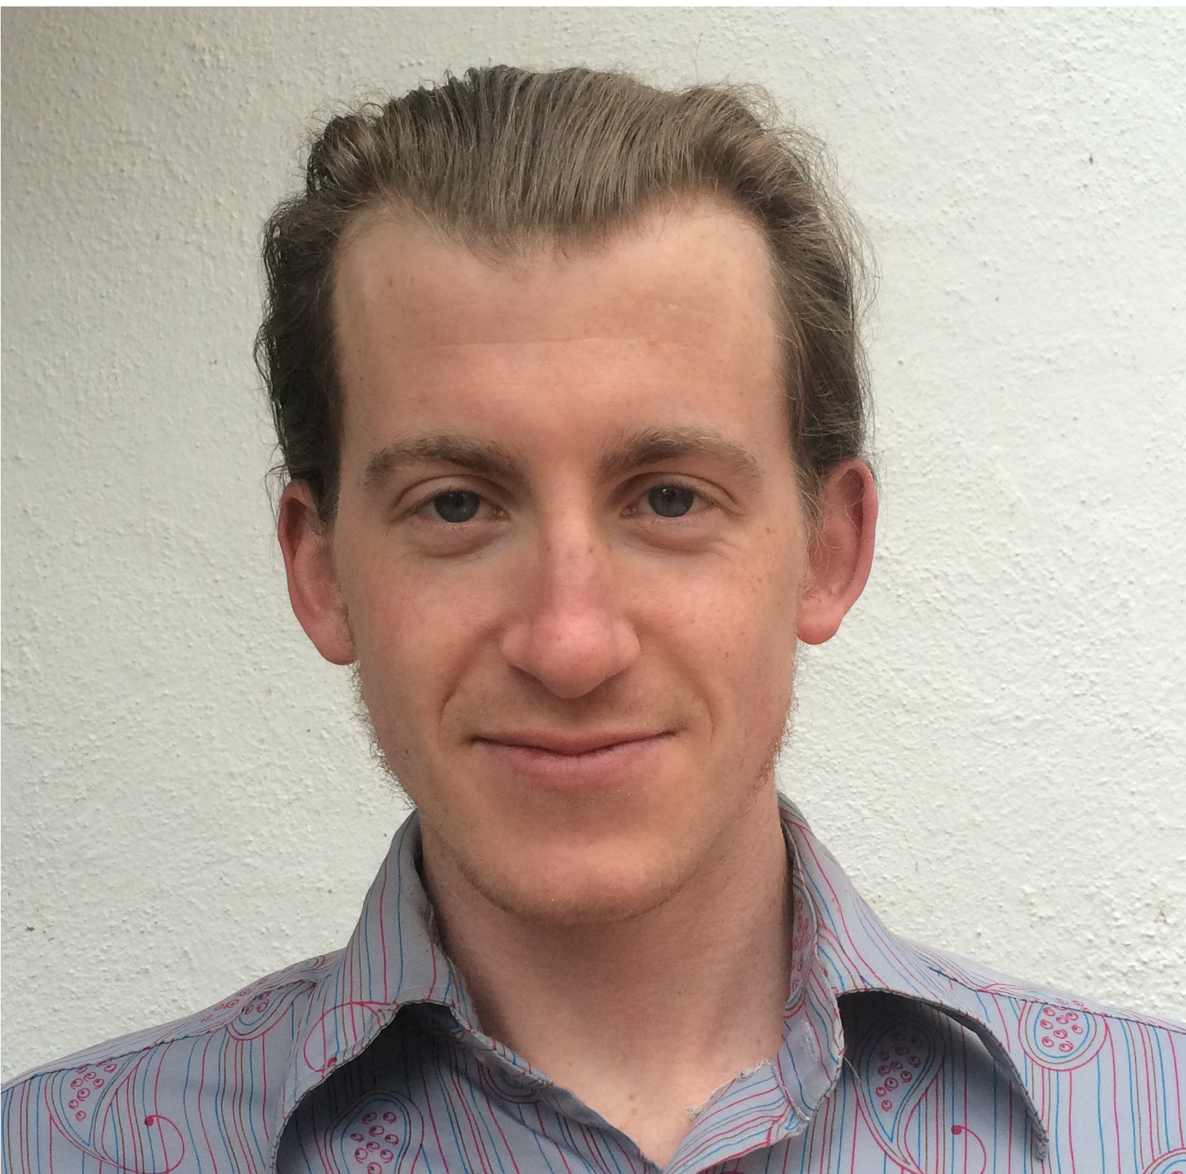
PERSONAL
Birth: U.S.A, 23-June-1989
Citizenship: American
Mother Tongue: English
Marital Status: Single
Health: Excellent

EDUCATION
2014: Bachelor of Arts – Sociology, North Carolina State University
With a German minor, Graduated Summa Cum Laude

EXPERIENCE
2014-Current: Bicycle Courier, Jimmy John’s Sandwich Shop
-Retain detailed knowledge of delivery range and local city geography
-Maintain peak physical fitness for daily job requirements
2011-2013: Coach/Route-setter, Triangle Rock Club
-Taught advanced climbing techniques and competition strategies to the
competitive youth climbing team (ages 5-18)
-Regularly set creative, new climbing routes to provide a fun and stimulating
challenge for team members and gym patrons
2010-2011: Sales Associate, New Balance Raleigh-Durham
-Interacted with customers and maintained an environment conducive to sales
2009-2010: Lifeguard/Instructor, Upper Limits Climbing Gym
-Responsible for belay lessons, climbing instruction, safety, and route setting
2006-2008: Counter Attendant, Hanson’s Cleaners
-Interacted with customers and processed payments, deliveries, and pick-ups

RELEVANT SKILLS & EXPERIENCE
CPR Certified
Foreign Languages: German
Travel Experience: Austria, Germany, Switzerland, France, Italy, Canada
Interests: rock climbing, the study of language, cooking

REFERENCES
Sumeet Kapoor Dr. Margaret Zahn
CEO/Founder, Shikshit Bhartiya Professor, North Carolina State University
Phone: 919-637-1293 Phone: 919-515-5946
Email: skapoor@ncsu.edu Email: margaret_zahn@ncsu.edu

