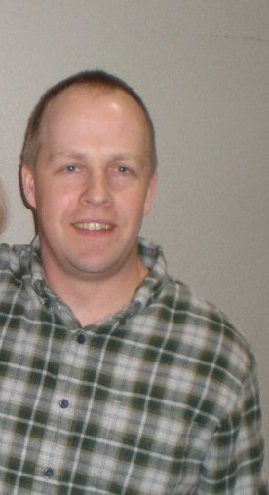
DANIEL KELLEY
cuger@hotmail.com
010-5944-6748
Work History:
February 2013-Present. Maple Bear Canadian Language Institute. Sodaemun. Seoul.
-February 2012-December 2012. Part time teaching and maintenance jobs in China and the USA while working on my second novel.
-February 2011-February 2012 Teacher at Korean International School Shenzhen, China.
-June 2010-January 2011 Completed novel, "Green Diamonds."
-July 2009-June 2010 Returned to Qwizdom, Inc.
-Sept. 2007-June 2009: Edupower Inc. Hong Kong. Teaching English from Preschool through Primary six. Curriculum Development, Editing.
-June 2004-June 2007: Qwizdom, Inc. Puyallup, Washington. Language arts curriculum and lesson development. Writing /editing curriculum. Inside/Outside Sales. Customer Service. Technical Support. Software Testing. Sales lead follow up. Convention. Customer Training. Product Demonstration. This job required many responsibilities, the ability to learn new things on a daily basis and a lot of interpersonal contact with customers.
-October 1995-May 2004: Various teaching posts in South Korea, Japan, Taiwan, Brazil,
Hong Kong and Seattle.
-May 1992-September 1995: Tanglewood Island Recreation Center. Various responsibilities, mostly involving customer service.
Publishing: “Green Diamonds” by Daniel W. Kelley March, 2011. On Amazon.
Education:
-Bachelor of Arts in English Literature. Washington State University, 1994.
-Phi Beta Kappa National Honor Society
-Basil and Ella Girard Award; Scholarship in English Studies
-President’s Honor Roll for each of nine semesters of attendance
-Cumulative GPA; 3.65
-GPA in Major; 3.77
-Senior writing tutor for Avery Composition Center.
-Bellevue Community College Publishing Institute
-Crafting Character Based Novel 2005-2007. Several classes concerning various aspects of fiction writing and character based novels.
Languages: English, Portuguese and Spanish.
Personal:
I consider myself to be a quick learner with a proven ability to adapt and endure in unique environments. Nearly all of my jobs have involved direct and constant interaction with people. I have become a good communicator with a strong ability to work with others. My language and writing skills are exceptional. I am published novelist. Please see "Green Diamonds" at Amazon.com for an example of my work. I am committed to a healthy lifestyle. My main hobbies are reading, writing and exercise.

