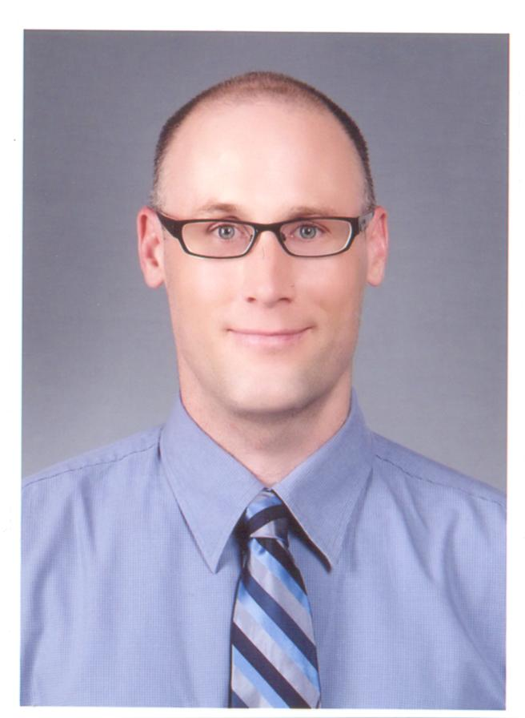

NAME: Daniel Robert Flanagan
D.O.B.: 1973/04/13
TEACHING EXPERIENCE

Rajamangkala University of Technology Krungthep, 2 Nanglinchee Rd., Thungmahamek, Sathon, Bangkok, Thailand, 10120, tel.: 02-2287-9600
Dates: from 2012/01 to 2013/04

- English Lecturer: Developed course content and was an instructor for the following classes; English for Tourism, English for Public Relations, Oral Presentations, and Intermediate Listening & Speaking. Volunteering for English Camps at provincial schools, participating in cultural events hosted by post-secondary students.

Anyang Foreign Language High School, 430-13 Gyeonggi-do, Anyang city, Manan-gu, Anyang 3-dong, 41-1, Korea, tel.: 031-4704-000
Dates: from 2010/8 to 2011/11

- English Teacher: Taught first year English conversation. Developed curriculum using the Jazz English textbook. Responsibilities included, making lessons, grading and giving tests, assigning final grades to students.

GEPIK-(Gyeonggi English Program in Korea), Shinsung Middle School, Korea,
Gyeonggi-do, Anyang city, Manan-gu, Anyang 6 dong, 587-68, Korea, tel.: 031-469-1411
Dates: from 2009/9 to 2010/8
- English Teacher: was an instructor for first, second and third grade conversational English classes. Responsibilities included using Power Point presentations and worksheets to supplement the school’s curriculum.
EPIK- (English Program in Korea)
During a two year period was placed at several schools throughout Jeju island while being employed by the EPIK program as an English teacher. Dates: from 2005/03 to 2007/03.
- Ohhyeon Middle School, Korea, Jeju-do, Jeju City, Hwabuk 1-dong, 4675, tel.: 064-755-9252, from: 2006/09 to: 2007/03. Taught first and second grades English conversation.

- Jeil Middle School, Korea, Jeju-do, Jeju City, Ido 2-dong, 539-4, tel.: 064-756-5971, from: 2006/09 to: 2007/03. Taught first and second grades conversational English.

- Seogwipo Life-Long Learning Center, Korea, Jeju-do, Jeju City, Donghong-dong 455-3, tel.: 064-732-7077, from: 2005/03 to: 2006/09. Taught elementary and adult English conversation classes.

- Hyodon Middle School, Korea, Jeju-do, Seogwipo City, Hahyo 1-dong, 4675, tel.: 064-755-9252, from: 2005/03 to: 2006/09. Taught first grade English conversation classes.

Daehan Academy, Jeju city, Ido 2 Dong 1176-17, Jeju-do, Korea, tel.: 064-702-5702
Dates: from 2004/03, to 2005/03
- English Teacher: developed and created English language lessons and taught middle school level students ages 11-14.

EDUCATION

The University of Winnipeg: 515 Portage Ave., Winnipeg, Manitoba, Canada, R3B-2E9, telephone: 1-(204) 786-7811
- Bachelor of Arts (4 year) -- major in Philosophy

REFERENCES
Can provide references upon request.

INTERESTS
Rock climbing, inline skating, cycling, traveling, and photography.

LANGUAGES
Advanced level in Korean, have an intermediate knowledge of German.

