Curriculum vitae of
Kgololo Andries Mokala
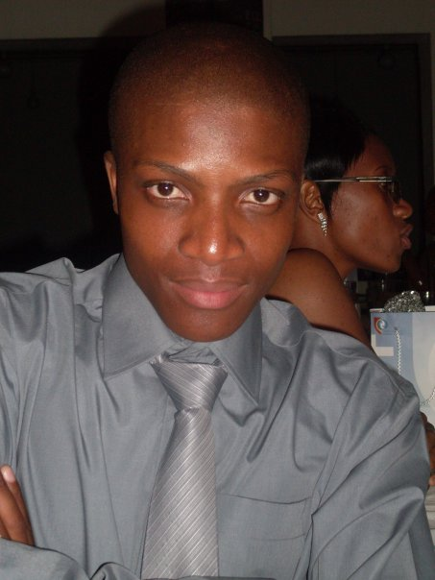
PERSONAL DETAILS
Surname : Mokala
First names : Kgololo Andries
Date of birth : 1990 March 07
Identity numbers : 9003 07 5909 080
Nationality : South African
Gender : Male
ADVANCED PERSONAL DETAILS

Home language : Setswana
Marital status : Single
Health : Excellent
Criminal record : None
Driver’s license : Learner’s License

CONTACT INFORMATION

Cell numbers : 073 520 9312
Next of kin (father) : 076 16 30391

Postal address : E 13332
: Zone 4
: Thaba ‘Nchu
Postal code : 9780

E-mail address : kgololo@yahoo.com

LANGUAGE PROFICIENCY
Language : English Afrikaans Setswana Sotho German

Speak : excellent : average : excellent : fair : average
Read : excellent : excellent : excellent : excellent : excellent
Write : excellent : excellent : excellent : fair : excellent

Understand : excellent : average : excellent : excellent : average

EDUCATION

SCHOOL EDUCATION

Name of school : Moroka High School
Highest grade passed : Grade 12
Year passed : 2007

SUBJECTS SYMBOL

English First Additional Language (HG) : D
Afrikaans Second Additional Language (HG) : C
Setswana First Language (HG) : B

Business Economics (HG) : B
Accounting (SG) : D
Economics (SG) : C

TERTIARY EDUCATION

Name of Institution : Central University of Technology, Free State
Qualification obtained : National Diploma Human Resources Management
Year obtained : 2010

: SUBJECTS Remark

First year subjects passed : Labour Law PD: distinction
: Business Management I PD: distinction
: Personnel Management I P : pass
: Accounting for Personnel Practitioners P : pass
: End User Computing P : pass

Second year subjects passed
: Communication in English P : pass
: Business Management II PD: distinction
: Personnel Management II P : pass
: Management of Training I P : pass
: Industrial Relations I PD: distinction

Third year subjects passed
: Business Management III P : Pass
: Personnel Management III PD: Distinction
: Management of Training II PD: Distinction
: Industrial Relations II PD: Distinction

OTHER SHORT COURSES COMPLETED

Name of institution : HTW Aalen University (Germany)
Qualification obtained : International business studies certificate
Year obtained : 2011

SUBJECTS : ECT Grade : Remark

: Strategic management : B : Very good
: Organizational behavior/studies : B : Very good
: Globalization, theory and practice : B : Very good
: Business English : A : Excellent
: Corporate strategy : D : Satisfactory
: Negotiation techniques : C : Good
: Case studies and planning games: B : Very good

Current qualification : Bachelors Degree in Human Resources Management
Year : 2011
Progress : Continuous

SUBJECTS

: Advanced management of training IV
: Advanced Human Resources management IV
: Advanced Industrial management IV
: Research methodology
: Advanced Strategic management IV
: Advanced Organizational behavior

COMPUTER LITERACY
: Microsoft Word
: Microsoft Excel
: Microsoft PowerPoint
: Internet Explorer
: E-mail

ACHIEVEMENTS AND AWARDS

Award : Boitsanape Computer Solutions Award
Year : 2005
Institution : Moroka High School

Award : Boitsnanpe Computer Certificate
Year : 2007
Institution : Moroka High School

Award : Reading Development Certificate
Year : 2008
Institution : Central University of Technology, Free State

Award : Human Resource Society Certificate
Year : 2008
Institution : Central University of Technology, Free State

Award : Wellness Worker Certificate
Year : 2009
Institution : Central University of Technology, Free State

Award : Peer Educator Certificate
Year : 2009
Institution : Central University of Technology, Free State

Award : Lesedi le chabile HIV & AIDS training certificate
Year : 2010
Institution : Central University of Technology Free State

EXTRA MURAL ACTIVITIES

Wellness Worker : 2009-2011
Human Resources Society Member : 2008-2010
Students in Free Enterprise Member : 2009-2010
South African Students Congress : 2009-2010
Young Communist League Member : 2009-2010

Leadership
Vice Chair-Person : Wellness Workers (2010)

REFERENCES

Personal References

Name : Mr. M. E. Monchusi
Company : TFD
Position : Assistant Driver
Relationship : Former Classmate (2005-2007)
Contact nr : 078) 697 5183

Academic References

Name : Mrs. M. E. Meje
Position : Teacher
Relationship : Former Business Management Class Teacher (2005-2007)
Institution : Moroka High School
Contact Nr : (083) 883 4413

Name : Mr. S. F. Jafta
Position : Lecturer
Relationship : Former Business Management Lecturer (2009)
Institution : Central University of Technology, Free State
Contact NR : (084) 659 0894

Name : Mrs. M. E. Mathibe
Position : Social Worker
Relationship : Wellness Worker Mentor
Office contact: 051 507 3443

PERSONALITY

Introverted but sociable
Agreeable and willing to explore new possibilities
Responsible and respectful
Clean and very hygienic

HOBBIES

: Watching reality TV & Talk shows
: Reading Newspapers
: Taking part in Public Debates

MOTTO

“The environment never throws at us what we cannot overcome. Taking initiative is the first step to making it happen”.

DECLARATION

I Kgololo Andries Mokala declare that; the above information is to the best of my knowledge true, accurate and a true account/reflection of my work & profile.

Note: all the awards and accreditations included are available should they be required & for any further clarification or information from my side my contact details provided above can be used at all times.

Signature _____________

Date _______________

