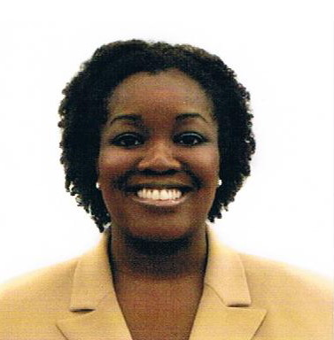 Colleen Elise Butler

First Name: Colleen
Family Name: Butler
Age: 06/30/78
Nationality: American
Current Location: Charlotte NC
Gender - female
Applying - alone
Teaching Experience: 1 year
Teaching_exp_details: I spent 1 year as a long-term substitute teacher in Wicomico Public School in Maryland and Preschool in Charlotte.
Character Traits: I am reliable, kind, helpful, and very friendly. I love to have fun in the classroom and to make things interesting for my students.

Date of Birth: 30th June 1978

Key skills
Communication skills
I received my training in Communication from Queens College.

Presentation skills
Developed through regular oral presentations and speaking events in my volunteer work for church.

People skills
Developed through various positions with government agencies, public school and in private jobs.

Cultural Understanding
I love to learn new languages and culture. I have studied French and American Sign Language. I am eager to learn Korean and have a great respect for the culture.

Education

05/2011-Present Bridge TEFL 100-hour Certification
Teaching English as a foreign language

9/1998 - 5/2002 Queens College
City University of New York, Flushing, NY
Bachelor of Arts Family and Consumer Studies

Member of the Phi Eta Sigma National Honour Society

Employment

04/2007 - Present Kids Inn Charlotte
Charlotte, NC
Office Intern
Record attendance and progress for all students.
Assist in preparation of videos, art projects and class work.
Prepare students daily food menu.
Update files as needed for entering or exiting students.

09/2006 - 03/2007 Wicomico County
Salisbury, MD
Substitute Teacher FCS
Grades 7-12 Family and Consumer Studies Department.
Taught food and nutrition, child development, parenting and life skills/adult living.

02/2005 - 07/2006 State of Delaware
Dover, Delaware
Senior Family Service Specialist
Case coordinator of community services, interview and application review for social services.
Case Manager and individual counselling sessions with children.
Write petitions to the State for legal custody of children in Family Court.

Special Duties: Interpreted for the Deaf using American Sign Language.

07/2003 - 01/2005 Nassau County Social Services
Uniondale, NY
Social Services Examiner I
Managed a caseload of approximately 100 clients.
Conducted interviews and collected documentation from customers to help determine need.
Determine eligibility of customers for social services programs.
Provide aid to eligible recipients with Day Care, Employment, Food, Medical and Home Energy assistance programs.

Interests
Film and music, studying American Sign Language and Korean culture. I recently attended the Asian American Pacific Film Festival in Los Angeles.

