Cover letter:

I am a South African citizen interested in starting a public school teaching job in Seoul later this year, as part of the SMOE August/September intake in 2010. I have 4 years teaching experience, including one year at a public school in South Korea. I completed a 120 hour full-time TEFL & TEYLT course at EC Cape Town and I also won the 2009 Best Native Teacher award for the Seobu district of Incheon, South Korea.

I will complete my current contract in Korea on March 4, 2010 after which I will travel Asiia for 3 months and spend 3 months at home in South Africa, in order to be ready for the next public school intake.

I will have my university transcripts and criminal record check ready to be submitted shortly before I leave Korea on March 4 this year, but will need to hold on to my passport until early June.

I look forward to hear from you soon.
Kind regards,
Christian Wink



Curriculum Vitae:

Christian Wink

Personal Information
Name: Christian Wink
Date of birth: 16 August 1984
ID no.: 8408165166080
Nationality: South African
Gender: Male
Ethnicity: Caucasian
Languages: Afrikaans - proficient writing and verbal skills
English - proficient writing and verbal skills
Contact Details
E-mail: christianwink1984@gmail.com
Telephone number: +27 (0)84 951 0222 (cell)
+27 (0)21 930 1584 (home)
Postal address: 10 Paarl Street
Panorama
7500
South Africa
Education
Secondary
Matriculated: Tygerberg High School (Western Cape) 1998-2002
Tertiary
BA(Socio Informatics): Stellenbosch University (2005)
Majors: Socio Informatics & Geography
Tertiary
HonsBA(Socio Informatics): Stellenbosch University (2006)
Tertiary
TEFL/TEYLT certificate (120 hours): EC Cape Town (2008)
WORK experience
4 March 2009 – 4 March 2010
Guest English Teacher: Bangchuk Middle School (Incheon, South Korea)
Description: Taught 22 classes a week, after-school classes and vacation campes at a public school and completed a one-year contract.
Teaching responsibilities:
- Teaching
- Preparing the classroom area
- Preparing all lesson plans and materials
- Student roll call

1 June 2007 – 31 January 2009
On-line teacher and assistant manager: Pangea Outsourcing Solutions
Description: Taught English Second Language conversation classes (Voice-over IP) for www.englishtown.com and managed more than 70 other teachers.
Teaching responsibilities:
- Teaching
- Assessment
Managerial responsibilities:
- Student feedback
- Teacher roll call
- Crisis management
- Teacher management
- Managerial report writing
- IT back-up support

1 February 2006 – 31 October 2006
Part-time teaching assistant: Information Science Department, Stellenbosch University
Description: Employed as a tutor for Information Skills 172, teaching four classes per week.
Responsibilities:
- Lecturing,
- Student roll call
- Overseeing examinations and tests
- Academic assistance.

1 September 2005 – 6 October 2005
Internship: Helderberg Manskoshuis
Description: Completed an information channel assessment for Helderberg male’s residence, a university hostel in Stellenbosch, which culminated in a presentation made for the primaria of 2005 and 2006.
Responsibilities:
- Construction, distribution and analysis of 180 surveys
- Recommendations for improvement of information channel efficiency

Skills
Communication and presentation skills
In the course of my honours degree I had the opportunity to render numerous presentations. This, along with my lecturing responsibilities, allowed me to develop my public speaking skills to a point where I feel comfortable and confident speaking in front of large groups of people. I see myself as a good communicator who has mastered the ability to convey any message or information clearly and accurately.

Computer skills
I have shown proficiency in operating MS Office applications such as Microsoft Word, PowerPoint, Excel and Access and internet concepts as I was given the opportunity to teach these applications and concepts to entry level students. My website development experience not only gave me the ability to understand the basic concepts and of languages such as HTML, XML, and PHP, but also gave me the ability to implement these as well. Furthermore, I have knowledge of databases, which include exposure to SQL and database Management Systems, such as RDBMS and OODMS. An introduction to the programming language Java was also part of my study syllabus. I have extensive knowledge of blogging and completed a dissertation on corporate blogging during my honours course.

Analytical
During my studies I was confronted with numerous problem situations. This allowed me to develop the ability to look at problems from different perspectives and consequently approach the problems with the appropriate solutions. Decision making, which comprised a big part of my curriculum, allowed me to understand fundamental aspects of organizational structures and functions. I have also been introduced to methods and concepts of analysing projects. Subsequently I have some experience in System Development Life Cycles (SDLCs) and Database Life Cycles (DBLCs) and knowledge of the Prince2 methodology. I also have extensive knowledge of Knowledge Management (KM) concepts as well as efficiency in operating KM tools such as Cmap. In addition to my extensive study career which included business oriented courses and IT theoretical concepts, I was able to understand fundamental aspects within organizations, such as process flows and how business entities’ function.

Interpersonal and leadership skills
I see myself as a people person who is able to work on tasks within groups or as an individual. I am also very much a team player with the ability to listen and provide guidance when needed. My studies gave me various opportunities to work in groups. During my career as an assistant lecturer and English teacher, I gained many skills with regards to aiding students in need of academic support by arranging additional classes and private tutoring sessions for my students. I also acquired leadership skills during my time as representative and first team captain of the table tennis team of my university residence, Helderberg Manskoshuis. As an assistant manager at Pangea Outsourcing Solutions, I managed more than 70 teachers, acting as an intermediary between staff and head management. During my time in South Korea I garnered invaluable skills and life experience that will permanently aid me to adapt to strange environments.

Interests, activities and awards
2004: Class representative – Socio Informatics 222
2004 – 2005: Member of PULP Film Society (University of Stellenbosch)
2005: Administrative representative and first team captain of Helderberg Manskoshuis tbletennis team
2007-2008: Production assistant for Tukston Films, Cape Town, South Africa
2009: Best Native Teacher of the Year, Seobu Office of Education, Incheon, South Korea
Other interests: Films, the internet, web logs, journalism, social networks, politics, camping, sports, music.
REFEREES
Han MiHye
English teacher: Bangchuk Middle School
Incheon, Gyeyang-Gu, Bakchon 1 gil 25, 407-480, South Korea
Telephone number: +82 032 556 4102/3
Fax number: +82 032 556 4105
E-mail address: hmh282@yahoo.co.kr

Tracy Cloete
Manager: Pangea Outsourcing Solutions
Bandwidth Barn, 125 Buitengracht Street
Cape Town, South Africa
Telephone number: +27 (0)21 409 7822
Fax number: +27 (0)21 409 7050
Cell phone number: +27 (0)78 204 0407
E-mail address: tracy.cloete@etteachers.com

Minnaar Pieters
Lecturer and coordinator for Information Skills 172 module (2006)
Information Science Department
University of Stellenbosch
Telephone number: +27 (0)21 808 2025
E-mail address: pietersm@sun.ac.za

Addendum A: Honours Degree

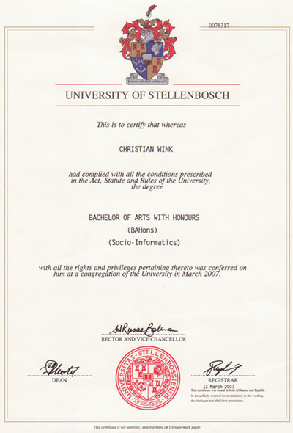
Addendum B: TEFL & TEYLT certificate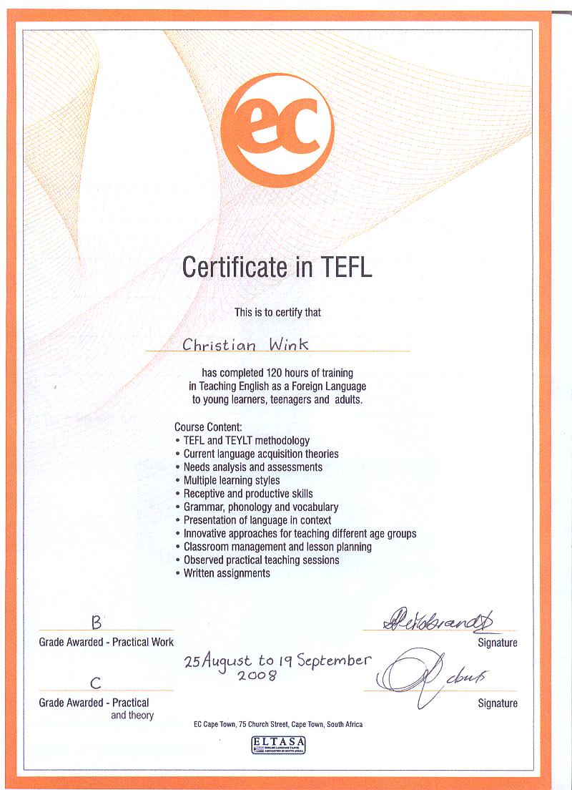
Addendum C: Teaching Award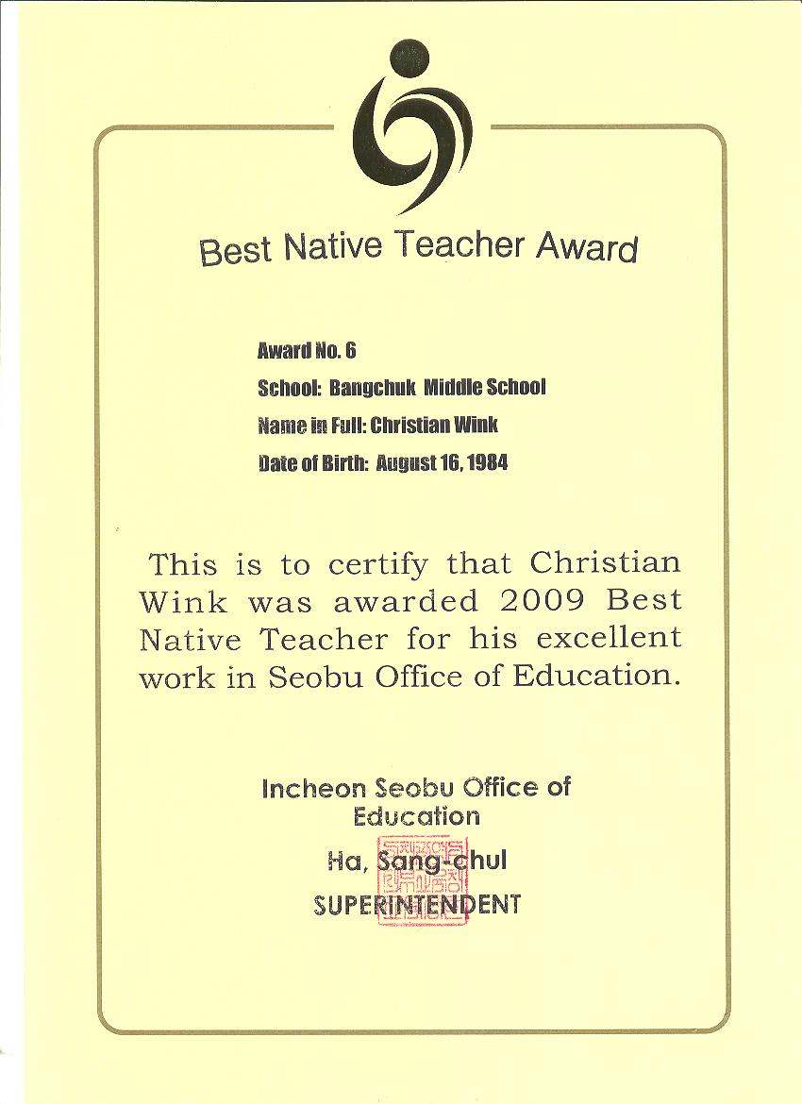
Addendum D: Letter of Recommendation
EC Language School

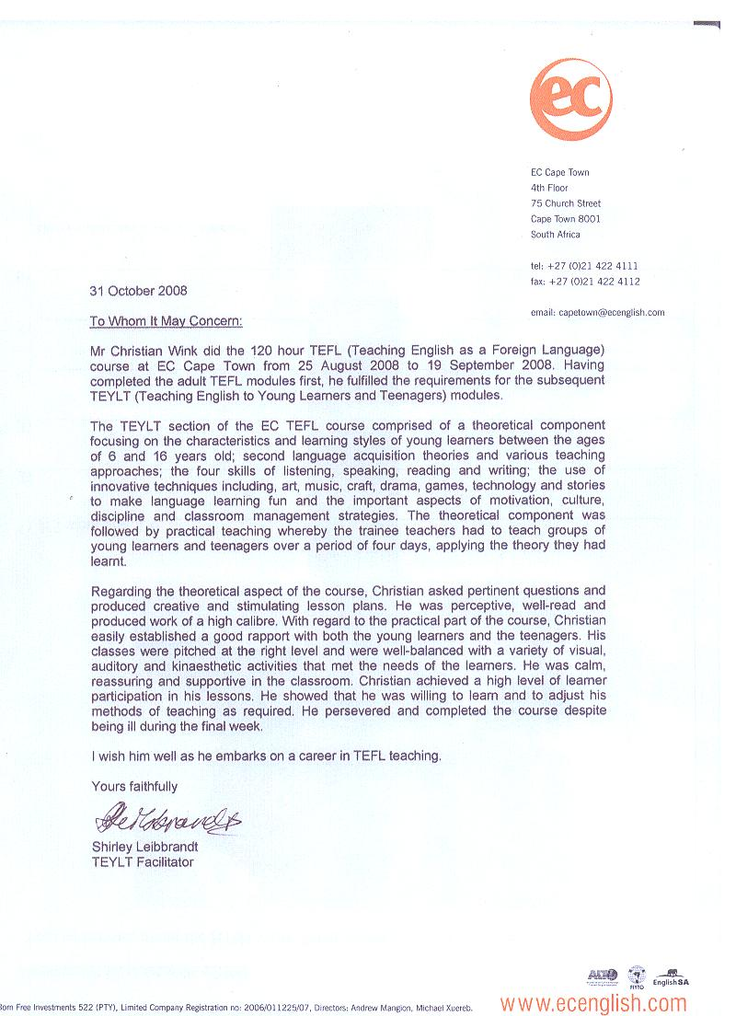

Addendum E: Letter of Recommendation
Pangea Outsourcing Solutions

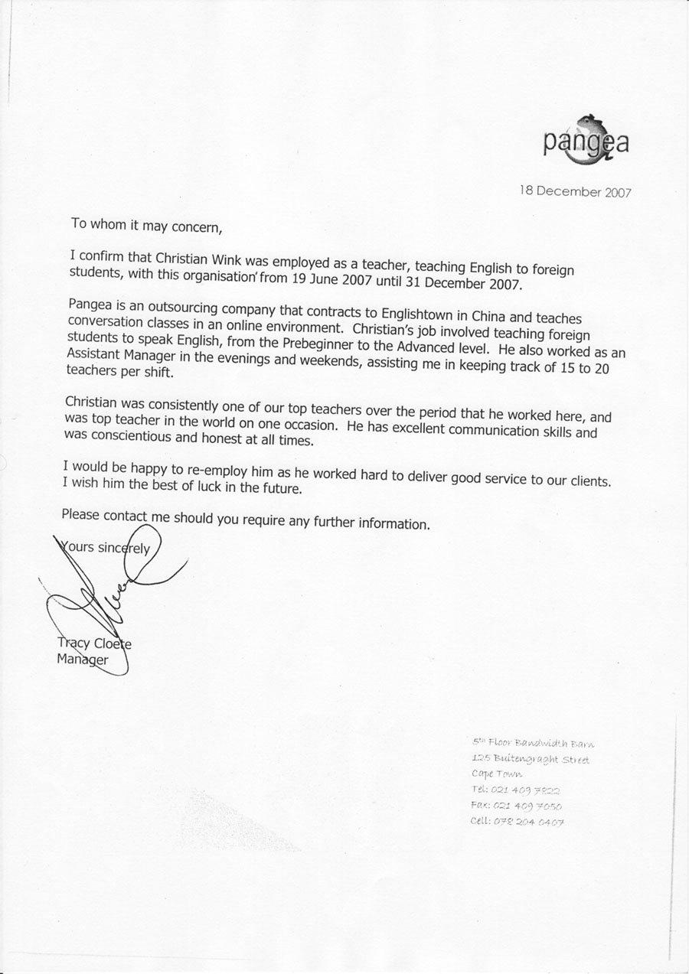
Addendum F: Letter of Recommendation
Stellenbosch University
