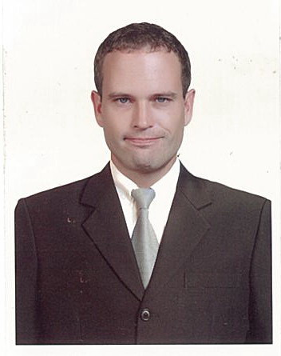
Joel Paul Morrison

Personal Data:

Date of birth: June 24, 1972
Birthplace: Washington, D.C., USA
Marital Status: Married
Nationality: American
Contact number: +14064396592 (US) +639955384236 (Philippines)
Email address: joelciloco@yahoo.com

Skype:majorjoel1972 LinkedIn:https://www.linkedin.com/profile/view?id=91647552&trk=nav_responsive_tab_profile

Lucky English International Center
Teda Building 2nd floor
Jiefangnan Road No.256
Hexi District
Tianjin 300000 People's Republic of China

English Teacher
May 2015-May2016

- Created lessons from scratch daily using Word, PowerPoint, using various other ESL resources available on the internet.
- Taught “public” classes such as English Corner
- Taught smaller classes and even one-to-one classes to high end clientele using their curriculum.
- Taught History, Geography, Western culture and other various topics to adults
- Organized social events at the center for holidays

King Saud Bin Abdullaziz University, College of Medical Sciences
Medical City
Jeddah 22384 Kingdom of Saudi Arabia

English Lecturer
February 2012-February 2014

- ENG 102 Communication Skills practicing conversation
- ENG 112 Language Structure and Drills teaching grammar using the text Fundamentals of English Grammar by Betty Schramfer Azar
- Created materials, weekly quizzes and semester examinations with several components.
- Served on the university’s website content review committee, in which I reviewed and edited material.
- Attended pedagogy seminars at KSAU COM in Riyadh at my own expense

Global IELTS International
9th floor, Wanda Centre
Saihan District
Hohhot 010010 People's Republic of China

English Teacher
March 2011-January 2012

- IELTS Module 2 (speaking) in Hohhot, Inner Mongolia, PRC.
- Taught large public classes such as English Corner on various topics
- Taught one-to-one classes to various age groups and levels using my own material
- Taught the Chinese staff when time allowed using my own material
- Participated in marketing campaigns to generate business

King Saud University
King Khalid Rd
King Saud University
Riyadh 12372 Kingdom of Saudi Arabia

English Lecturer
January 2010- January 2011

- ENG 101 using Cambridge materials
- Created weekly quizzes and semester examinations with several components, invigilated KET and PET exams
- Attended and contributed to several professional development workshops
- Taught engineering as well as medical students of varying levels in the PYP program
- Without any prompting, towards the end of the year my entire class together went to student services to recommend me due to helping them exponentially increase their ability in writing

Sarasas Bilingual Schools
48 Moo 4 Nimitmai Rd.
Khlong Sam Wa
Bangkok 10510 Thailand

English Teacher
October 2006-September 2010

- EFL KG1
- EFL Science/Social Studies Grades 1-3
- EFL Social Studies Grades 7-12
- Worked on the school newspaper
- Created all the quizzes and exams for aforementioned classes

Educational Attainment:

Primary:

Saint Patrick’s Episcopal Day School
Washington D.C., USA

Secondary:
Capital High school
Helena, MT USA

College:

Gordon University
Port Dinorwic, Gwynedd, Wales
United Kingdom
Bachelor of Science in Business Administration

TEFL Intercontinental
Jomtien City
Kingdom of Thailand
TEFL Certification

Languages:

French
Thai (50%)

