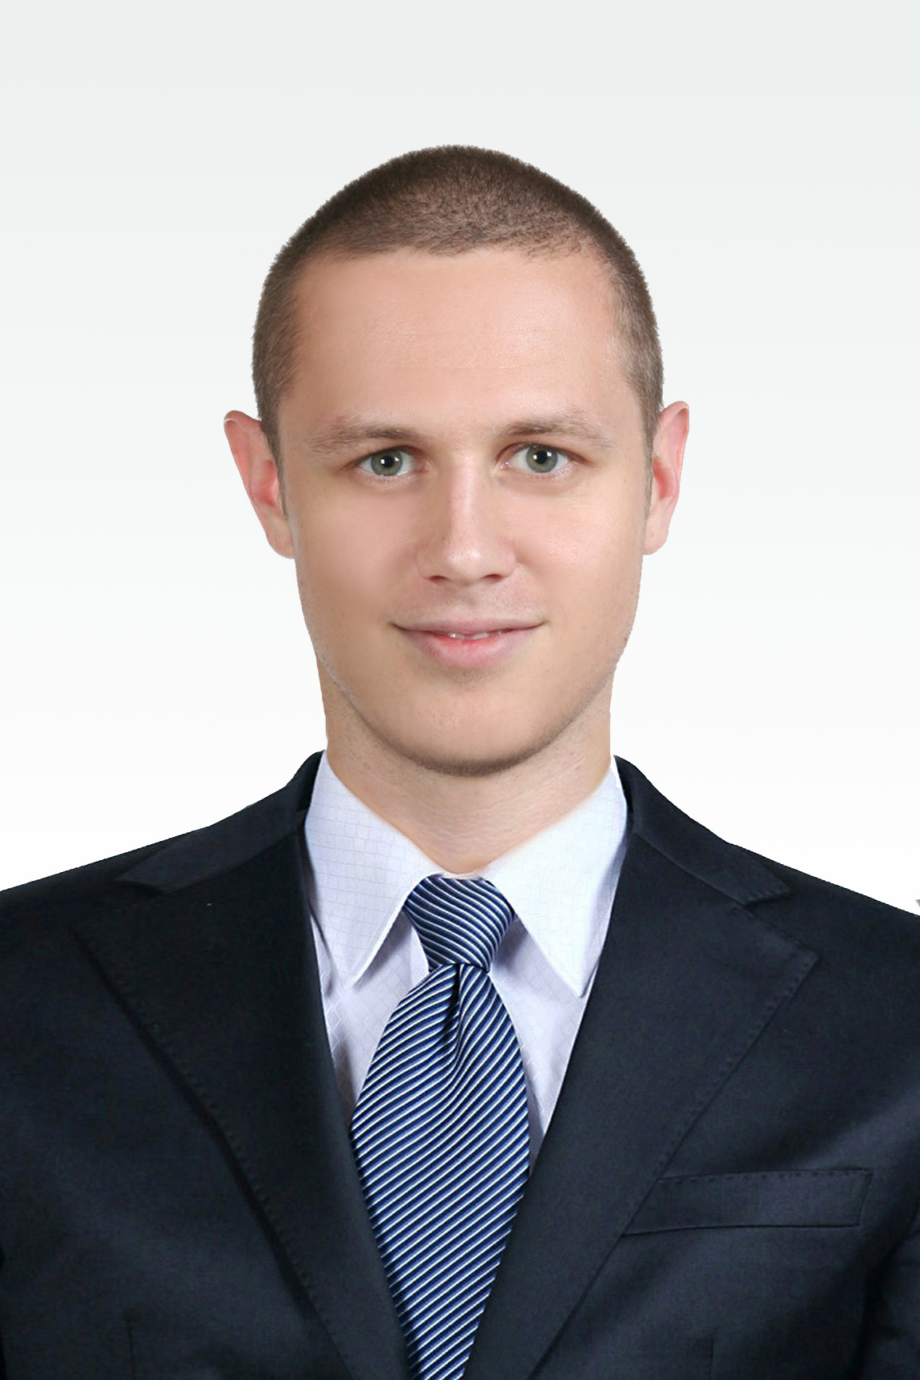
James Coakley james.c.coakley@gmail.com
Nationality: American 070-4068-9858
DOB: July 7th 1981 서울 도봉구 방학1동 719-2, 북한산
Visa status: F-2
PROFILE
The first time I came to Korea was in February 2008. I was an exchange student at Yonsei University, studying North Korean/South Korean political relations. Afterwards, I chose to remain in Korea to study the Korean language. During that time, I met my wife and made the decision to permanently remain in Korea.
TEACHING APPROACH
Student Centered: Students learn and remember by doing, so active participation is paramount, the teacher adopting the role of passive facilitator. The classroom is a stage on which the students perform, rather than the teacher. Realistic: Learning a language is not unlike mastering a musical instrument. It takes time, there are no magic formulas, the teacher can provide an ideal environment to learn but the student’s desire to learn determines their level of progress. Optimistic: English is a naturally flexible and adaptive language; it has travelled the world and is all around us. It is the most learned language in the world. This ubiquitous and easy access to English makes it possible for anyone to master the language. Communicative: Owing to its inherent flexibility, English can be well understood even with poor grammar and pronunciation. The message is more important than the delivery.
EXPERIENCE
Private English Tutor 2004-2010
The majority of my students were Korean office workers and students from the top Korean Universities in Seoul. I studied different methods of teaching, while incorporating methods learned from other teachers. Many of my students remain close friends, and I found great pleasure in educating adults, through the English language, in all manners of subjects.
University of Denver International Orientation Leader 2007-2008

I aided, assisted, trained and taught incoming international students about life at the University of Denver and in America. Within the International Students Organization I provided orientations for new international students and scholars, cross-cultural adjustment assistance, and helped organize international programs and events.
EDUCATION
BA, International Studies University of Denver
Korean Level 2 Sogang University
Korean Level 1 Yonsei University

