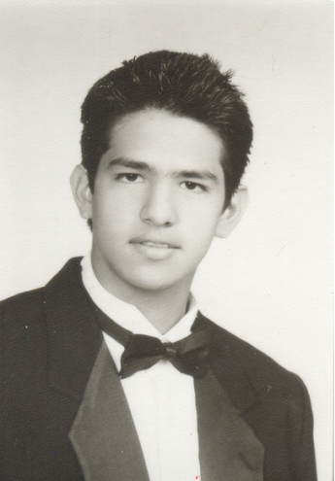
Curriculum Vitae

Personal Information:

Name: Carlos Alfonso Olivo Hassín
Place and Date of Birth: 19 of September 1987/ San Salvador, El Salvador
Nationality: Salvadorean
Civil State: Single
Personal Address: Anam 2 International Student Residence, Anam residence life, Korea University, Anam dong, Seogbuk Ku, Seoul 136 701 Korea
Telefophone number: 02 3290-0517
Mobile phone: 010 2349-8719
E-mail:. olivo88@hotmail.com Alternative Email: olivocarlos2007@abc.edu.sv

Academic Experience:

Academic Background: Time Period
Korea University –International Studies March 2009- Present
Seoul National University- Korean Language Course June 2008- January 2009
IB (International Baccalaureate) endorsed by Cambridge University August 2005- June 2007
Bachelor degree from Academia Britanica Cuscatleca August 1994-June 2007
IGCSE studies endorsed by Cambridge University August 2003-June 2005
International Award (IAA) August 2005-March 2007

Labor Experience:

Sykes (Agent) – Ford Credit June 2007
Recyling International (Assistant) June 2006- January 2007
Wackenhut (Assistant of the accountant) May 2005
Summer Camp British School (Monitor) June 2004/2005- July 2004/2005

Languages:
Language: Spoken and written level
English: Advance
Spanish: Advance
French: Intermediate
Korean Intermediate

Computing Knowledge:
-Microsoft: Word, Excel, Powerpoint, Access, Front Page, Advance
- Java programming language Basic

Other Peritinent Information:
Clean driving licence- own since 2006

