CURRICULUM VITAE

Johannes Tobias Louw

Cover Letter/ Personal essay

My name is Johannes Tobias Louw. I am a South African citizen with three years experience in education. I recently completed my B.Ed degree.

Whilst busy with my degree I had the opportunity to work and gain experience. First as a teaching assistant, then as a reading support teacher and also as a class teacher responsible for the regular duties of a class teacher as well as the responsibility of giving reading support to grade 3-6 students.

Being organised is very important to me. Having a classroom that is properly managed and organised will go a long way to ensure the safety of everyone in the class and to enable students to maximize their potential. I believe that we can only maximize potential if we accept that every child is different and that our teaching strategies should be differentiated to meet the diversity of the children in our class.

My teaching philosophy is that each child has the right to a good education regardless of that child’s ability. I love children and would like to be part of making sure they get the best education to have a better future. Children are our future and it is up to us as educators to make sure that we point them in the right direction to ensure they become lifelong learners and well adapted citizens.

I am an adventurous person who loves the outdoors. I am the type of person who will always try to help others. My hobbies include fishing, camping and playing darts. Core values are important to me and that is why I like spending time with family and friends.

Johannes Louw

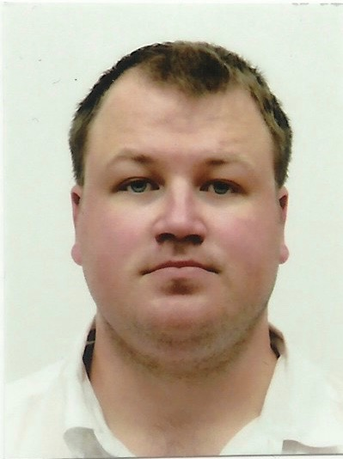

1. Biographical Information

  - Full name and surname: Johannes Tobias Louw

1.2 ID number: 8601315208089

1.3 Date of birth: 31 January 1986

1.4 Place of birth: Bellville, Western Cape, South Africa

1.5 Nationality: South African Citizen

1.6 Marital status: Single

1.7 Address: 9 Alikreukel Street, Glentana
Mossel Bay
6525

1.8 E-mail: jt.louw@gmail.com

1.9 Skype name: johannes.louw31

1.10 Cell number (SA): +27 82 451 6994

2. Academic Background

2.1 2004: Grade 12 – Oakdale Agricultural High School

(Sport and cultural activities: Rugby, athletics and was part of the school choir from Grade 8 to Grade 12.)

2.2 2016: Graduated from the University of South Africa (UNISA) with a Bachelors Degree in Education (B.Ed: Intermediate and Senior Phase). Main subjects are Geography and English.

3. Work Experience 2005 – present

3.1 Private Sector 2005 – 2011

- 2005: Work in the USA as a bee-keeper at Roeder Honey Farms.

- 2006 – 2008: Garden Route Construction Enterprise: building and installing kitchen and bedroom cupboards.

- 2009 – 2011: Texas Farm (USA):
Worked in breeding as well as at the Finishers and Nursery. Most of my experience is in farrowing, worked in the middle (7 – 14 day old pigs) and big (14 – 21 day old pigs) rooms.

4.Teaching Experience

- 2013 – 2014: Deira Private School, Dubai: Teaching Assistant

- 2014 – 2016: The Oxford School (Dubai):
English Reading Support teacher. My general duties were to assist students from Year 3 to Year 6 who had difficulty reading and pronouncing basic words and to get them to a level where they could read and work on their own.

- In 2016: Class teacher for Year 6 and taught value education to the Year 6 students. Created a reading program that helped the students practice sight words and phonics and determine what their level of reading is. The program insured that the students were reading books suited to their reading ability and in the end helped them to improve their reading levels.

4. References

- David Berry, Site Supervisor at Texas Farm: +1806-228-0002

- Reference letter from the principal at The Oxford School, Dubai

- Experience certificate from the HR at The Oxford School, Dubai
