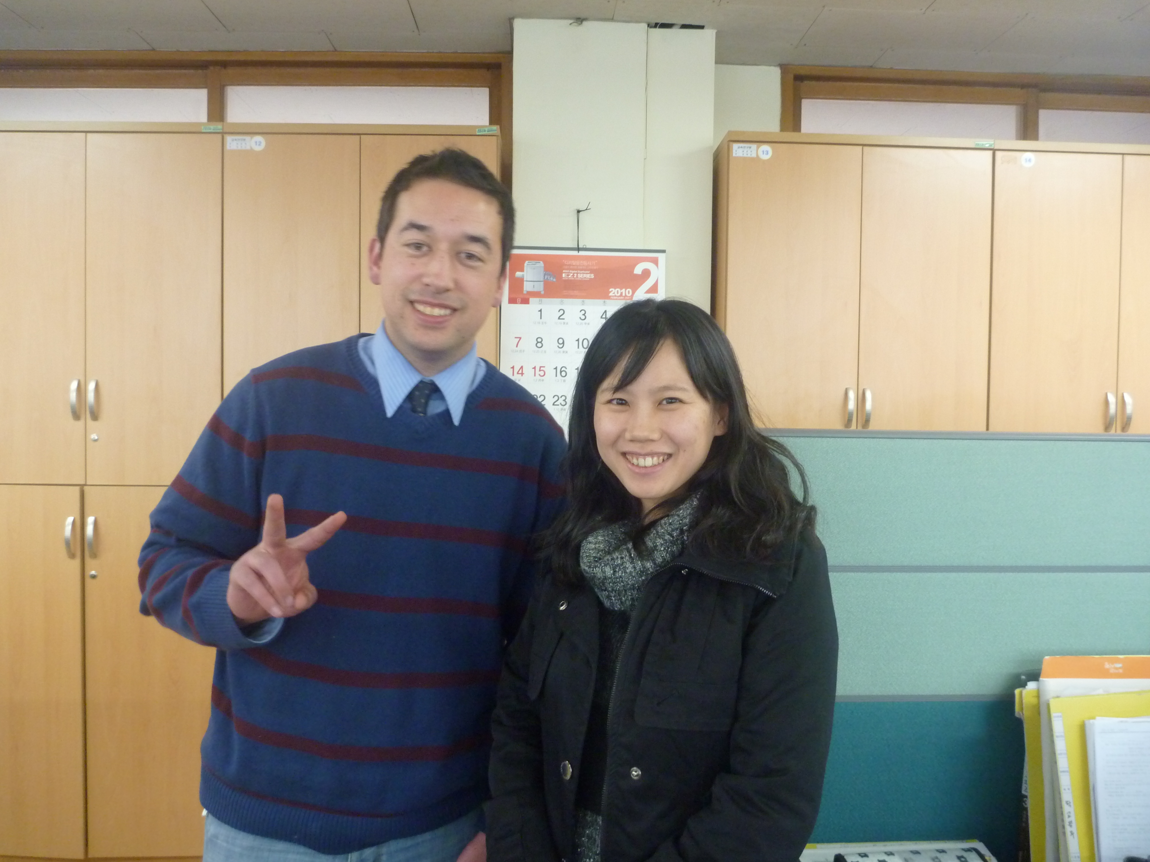
Brian J. Coughlin
Gyeonggi Do, Bucheon Si, Wonmi Gu,
Sang 1 Dong, 1415 Kumgang
brcoughlin@gmail.com
(010) 7721-2558

Summary:
Experienced ESL teacher. Enjoys talking with students during office hours. Able to work well with others and meet deadlines. Great communication and organizational skills. Able to integrate custom PPT presentations into lessons.

Education:
B.S. in Business Administration, 12/19/2008
San Jose State University
San Jose, California, USA

Employment History:

Native English Teacher October 2009-October 2010

Buin Middle School, Bucheon, Gyeonggi Do
- Selected and coached school's team which won first place in Bucheon's English speaking contest
- Develops fun games used to facilitate learning
- Taught debate and pre-intermediate English after school

Collections Specialist August 2008-December 2008
Pacific Plumbing, Redwood City, CA
- Reduced outstanding Accounts Receivables balance by 20 percent
- Assisted in preparing bids for large-scale plumbing projects within deadlines
- Designed an Excel macro which made billing more accurate, fast, and easy
- Designed and updated pivot tables to keep track of materials

Teller September 2003- January 2006
Wells Fargo Bank, Redwood City, CA
- Accurately processed customer transactions
- Insured appropriate cash balance in vault
- Reconciled balances of traveler's checks and credit card sales
- Analyzed customer accounts and recommended improvements

Activities:
Operational Auditor
American Cancer Society, Bay Area, CA April 2007- September 2007
- Supervised 24 hour fundraising activities insuring that liabilities were minimized
- Reported audit results to the finance department for review and further instruction

Treasurer
Colleges Against Cancer, San Jose, CA September 2007 - May 2008
- Successfully procured equipment and liability insurance for cancer prevention event
- Developed a plan for designated smoking areas on campus

