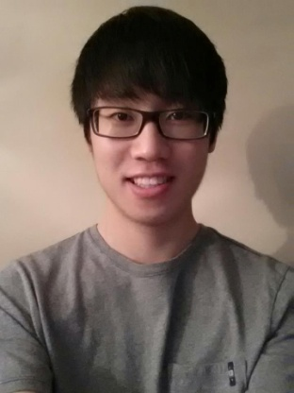

Andrew Shin
And2591@yahoo.com
Morton Grove, IL
224-522-4908

Personal
Date of Birth: June 25, 1991

Education
2013: Loyola University Chicago, Chicago, IL
Bachelor of Science in Biology

Work Experience
English Tutor
- I tutored conversational English to 14 pre-dental hygiene students from Sahmyook University during summer of 2012. We worked on basic grammar, conversational workshops (emphasis on dental clinic), and English presentations.

- Also, I have tutored English to a foreign church member for several months when he immigrated to America from China.

Church Leader
- I am the social activities coordinator at my church. I’m involved with planning and organizing after church activities for members of all ages. As the social activities coordinator, I have experience working with kids ranging from primary to high school.
Church Outreach
- In college, I participated in leading out the children’s program of a church in Chicago with other campus ministry members. It involved acting in a play, singing songs, and doing various activities with the children.

Other Work Experience
Pharmacy Technician
- I worked as a pharmacy technician in an outpatient pharmacy located inside a hospital. My responsibilities include counting, labeling, and dispensing medications with careful precision and focus. I also work at the cash register and interact with customers who come to the pharmacy.

Chicago Botanic Garden Researcher
- During the summer of 2012, I worked as a research intern at Chicago Botanic Garden doing plant research. The plant research involved paying attention to details and patience.
Organization
Pre-Pharmacy Club
- I served as the public relations officer for the Pre-Pharmacy Club at Loyola University Chicago. My responsibilities included going to monthly meetings, speaking in front of the pre-pharmacy club members, and introducing other students about pharmacy as a career.

Achievements
- I was awarded for presenting my biological research in front of professors and mentors at the 2013 LUC Biology Research Symposium.

Language
- I speak fluent English and Korean.
- 4 years of Spanish in high school

Personal Interest
- Basketball
- Dancing
- Singing
- Traveling

