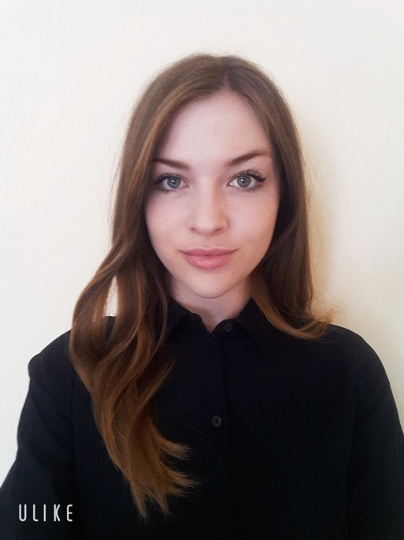
Amber Ward
ESL and EAP English Teacher
ambertegan@icloud.com
07878065151

Applicant Summary
I am an ESL teacher from the United Kingdom with over six years of experience in the ESL teaching community and a career spanning four countries. I am well-versed and confident in my abilities to teach English to non-native speakers in a structured but also exciting environment. I am also adept at creating detailed and appropriately staged lesson plans and my creative take on projects lends itself very well to preparation of teaching materials for a class. I pride myself on my ability to create level and age appropriate, personalized lessons for all learners. I have a wide range of experience teaching different age ranges from 2 years old to senior adults, all levels from A1 to C2 level learners and class sizes from as big as 40 students to private 1 on 1 lessons. Over the last few years. I have taught in a variety of language establishments ranging from private kindergartens to university. I have achieved a 140-hour TEFL certification, as well as a Pass B grade CELTA, and I know that with these academic qualifications, plus my own personal skills, I am a great asset to any company or school.

Education

University of Plymouth, UK
BA (Hons) English 2:1 Bachelors Degree achieved in English
CELTA Pass B, Cambridge UK
Successful completion of 4 week CELTA course within the highest scoring group on this particular course completed in Saigon, Vietnam
TEFL England, UK
Successful completion of 140 hour TEFL certificate in Plymouth, UK
St Austell College, UK
4 A-Levels achieved including A in English Language and Literature

Experience
PRE-SESSIONAL TUTOR OF ACADEMIC ENGLISH, CANVARD COLLEGE BEIJING UNIVERSITY OF BUSINESS AND TECHNOLOGY and UNIVERSITY OF PLYMOUTH; BEIJING, CHINA/PLYMOUTH, UK —
JUNE 2019 – PRESENT (contract ending September 5^{th 2019})
At this job, I have taken my first leap into the world of higher education teaching. It has been my most rewarding job so far. In this job role, I have taken on the responsibilities and unique challenges that comes with teaching at higher education facilities as a lecturer of Academic English on two different pre-sessional courses in both China and England. I put together concise daily lectures and activities focusing on Academic English to help improve their skills and confidence.
ENGLISH TEACHER/SOCIAL MEDIA MANAGER, LESSON4U; KANZAWA, JAPAN — 2018-2019
At Lesson4U, I continued to expand my own personal knowledge of the technicalities of English grammar by teaching more advanced adults. In this job I was also trained to perform interview practice for Japan’s EIKEN test. I also took charge of managing the Instagram account for this school, which gave me invaluable experience in social media. I made weekly videos for the school demonstrating English phrases and idioms for English learners.
ENGLISH TEACHER ARTLINGUAL; HIROSHIMA, JAPAN — 2017-2018
In my first year as a teacher in Japan, I gained experience teaching adult classes, both group and private lessons, to an extremely varied range of levels and learners. I taught at many outside companies to groups of business people, as well as to more niche learners such as a yoga class. I also taught to various kindergartens, helping children of under 4 years old learn the very basics of English.

ENGLISH TEACHER, ILA VIETNAM; HO CHI MINH CITY, VIETNAM — 2015-2016
At ILA Vietnam, the largest and most prestigious English academy in all of Vietnam, I gained valuable experience teaching larger classes, sometimes teaching up to 40 children in a public school class. I also had the chance to teach longer lessons of up to two hours, which gave me freedom to create more detailed and activity based lessons for my students.
ENGLISH TEACHER, GDA JUNIOR SCHOOL; BUNDANG, SOUTH KOREA —
2013-2015
My first work as an ESL teacher was as the primary English teacher for kindergarten students involved in an intensive English program. Not only did I teach them English, grammar and conversation, but also Math, Science and Social Studies. I also regularly took part in extracurricular activities such as field trips, sports days and parent teacher meetings. This job gave me essential experience as a teacher to children, and creating daily lesson plans following a set textbook curriculum.

Skills Summary
- Lesson planning – extensive experience in detailed planning of all kinds of lessons
- Customer service background – ability to effectively communicate with customers
- Preparation of materials – resourceful and creative attitude allows me to prepare effective learning content
- Acting and theatre background – I am extremely confident and enjoy speaking in front of large groups of people
- Proficient with technology and office software – I regularly make use of computer office software and use it appropriately in my classes
- Basic childcare – extensive experience with children from ages as young as 2 years old
- Social media proficiency – managed a popular account with a regular posting schedule for previous employer
- Clean UK and Japanese drivers license
- Interest and skill in learning new languages – I am able to read and write Korean (한글), and intend to study Korean more formally during my time in South Korea. Along with this, I have known the basics of the languages of the countries I have lived in. I am often complemented on my ability to understand new languages relatively quickly.

Charity Work
Whilst living in Vietnam, I volunteered weekly to teach English to orphaned children with learning difficulties and physical disabilities at Go Vap Orphanage (45 Nguyen Van Bao Street, Saigon, Vietnam).
References
References will be provided upon request.

Thank you for taking the time to read my resume.
If you have any further questions please do not hesitate to contact me.
I hope to hear from you soon.

