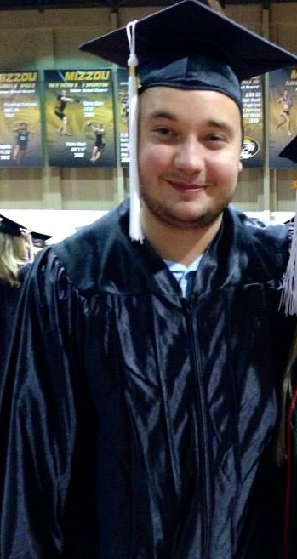

Charlie Kempf
- 12204 Blackheath ct. • St. Louis • Missouri • 63141 • U.S.A.
- Email: CMKZMB@mail.missouri.edu • Mobile/Cell:314-2832205

Marital Status: Single
Nationality: American
August 7, 1991
Gender: Male

Objective

To teach at a private language institute in South Korea where I can develop my skills and knowledge as an educator

Education

University of Missouri, Columbia, Missouri.
Bachelor of Science – August 2014
Bachelors of Science: History
Minor: Political Science

Teaching and Related Experience

Mizzou Language Partners, Columbia Missouri – 2013-2014
•Assisted non-native English speakers with conversational English
•Gained an awareness and learned about new cultures
•Aided students of foreign languages with their speaking, listening, and communication skills through constant practice

Special Olympics Volunteer, St. Louis Missouri – 2008-2010
•Provided a welcoming and accepting environment for all of the athletes and their families
•Aided participants with getting to events on time
•Responsible for the coordination of the activities

Work Experience

Mad Cow Restaurant, Columbia Missouri – 2011-2013
•Responsibilities included taking customers’ orders, providing exceptional customer service to restaurant patrons, and training new employees.

Child Care Provider, St. Louis Missouri – 2009-2011
•Supervised two children aged 8 and maintained a safe, clean, and appealing environment. I also tended to the physical needs of the children and was responsible for their well-being.

Travel Experience

•Busan, South Korea – 2 weeks.
•Incheon, Sougth Korea – 2 weeks
•Bangkok, Thailand – 3 weeks
•Barcelona, Spain – 2 weeks

Computer/Language Skills

•Fluent in English
•Proficient with Microsoft Word, Excel, and PowerPoint

References

•Available upon request

