RYU ALICE JAEYEON
Tema Building, Baekjaegobun-ro 468-1, Songpa-gu, Seoul, Korea

E-Mail: alicer518@gmail.com

Tel: 010-5559-6136

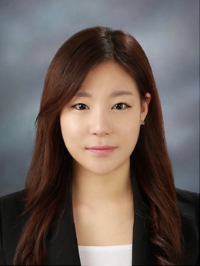

PERSONAL INFORMATION

~ Born in Seoul, Korea in May 18, 1989

~ Left Korea in 2004 and moved to the United States

~ Citizenship in the United States

EDUCATION
UNIVERSITY OF ILLINOIS AT CHICAGO 2008 - 2013
~ Bachelor of Psychology, graduated in December 2013
GEORGE WALTON HIGH SCHOOL, MARIETTA, GA 2005 - 2008
~ Diploma received in August 2008
WORK EXPERIENCE
TRAVEL AGENT 2009 - 2010
~ Worked as a travel agent at Lotte Travel Agency in Chicago, IL
~ Responsible for selling, issuing tickets, and communicating with clients
ASSISTANT TEACHER AT LOCAL KOREAN SCHOOL 2007 - 2008
~Teaching young learners (4-14) whose mother-tongue is not Korean.
~Improved the ability to approach students for comfortable studying environment

