Genevieve M. Tecson 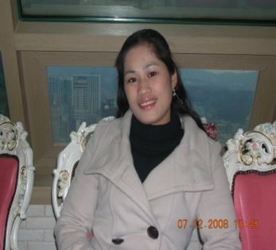
F21 Visa Holder
Contact : # 010-4196-3294
Address : Yongin City Suji Ku Pongdeokchon 1dong
Tongbu Apt 103-603

POSITIONED DESIRED : TEACHER

Special Skills – Good in both written and oral communications,
Highly develop in Personal Relations,

PERSONAL DATA :

Provincial Address : Bansalan Davao del Sur
City Address : Davao del Sur
Date of Birth :June 04, 1983
Age : 26 years old
Sex :Female
Nationality : Filipino
Civil Status : Married
Religion : Roman Catholic
Height : 5’4”
Weight : 110 bls
Name of Spouse : Mr. Sangdu Bae
Contact# : 011-429-3294

EDUCATIONAL BACKROUND:

COLLEGE:
2000-2002 Information Technology ( IT )
Advance Computer Technical school
Bansalan, Davao del Sur

SECONDARY:
1996-2000 Marber National High School
Marber, Bansalan Davao del Sur

ELEMENTARY:
1990-1996 Bansalan Central Elementary School
Bansalan, Davao del Sur

